**Fi-Ware Social Proximity App**

Vision Document & Functional Specification

Joshua Eisikovits: C00156665

Project Supervisor: Dr Chris Meudec

17/04/2015

Table of Contents

Vision Document 4

Introduction 4

Context Diagram 4

Fluid UI Prototypes (GUI Mockups) 5

Targeted Users & Benefits 6

Primary 6

Secondary 6

Benefits 6

Key factors to judge quality 6

Main Functionalities 6

Main Risks Summary 6

Business Risks 6

Technological Risks 7

Project Risks 7

Functional Specification 7

Introduction 7

Purpose 7

Scope 7

Overall Description 7

Product Perspective 7

Product Functions 8

User Classes and Characteristics 8

Operating Environment 8

Design and Implementation Constraints 8

Assumptions 9

Specific Requirements 9

External Interface Requirements 9

User Interface 9

Communication Interfaces 10

System Functionality 10

Create Profile 10

Start Anonymous Chat 10

Provide Location 10

Search Event 10

Create Events 10

Social Media Enthusiasts 11

Event Organisers 11

Supplementary Specification 12

Objectives 12

FURPS 12

Functionality 12

Connectivity 12

Usability 12

Localization 12

Feedback 12

Look and Feel 12

Ease of Use 12

Reliability 12

Availability 12

Supportability 12

Reusability 12

Use Case Diagram 13

Brief Use Cases 14

Detailed Use Cases 15

Vision Document

Introduction

The aim of my project is to produce a smartphone app in which users can register their current centre of interests (hobbies, sports etc.). All information entered from the user must be stored using the Fi-Ware technology (the EU sponsored cloud solution).

The main goal of the project is to deliver a robust social networking app based on clients’ personal interests and locations. It is proposed that this will be achieved by:

* Create a mobile application.
* Create a cloud-based application using Fi-Ware technology.
* Allow Event Organisers to create events using a web based application.
* Allow mobile clients to interact (chat) with one another anonymously within the same vicinity

With the vast majority of the world’s population owning a smartphone it has become easier for mobile owners worldwide to download mobile apps. In June 2014 over 75 billion apps [2] were downloaded just from the Apple Store, this is not including the Google Play Store or other competitors. This app could give social users help in finding other users close by who are interested in the same social aspects as themselves. I believe that my target users will appreciate this value proposition.

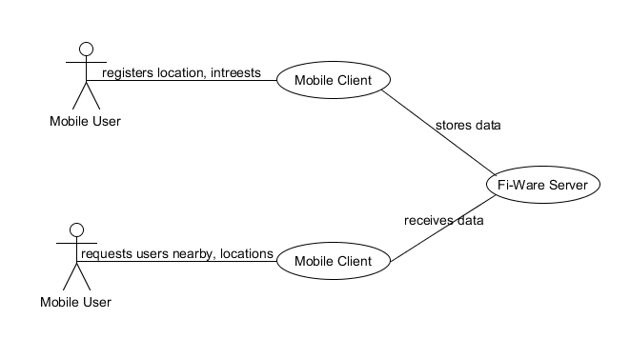

Context Diagram

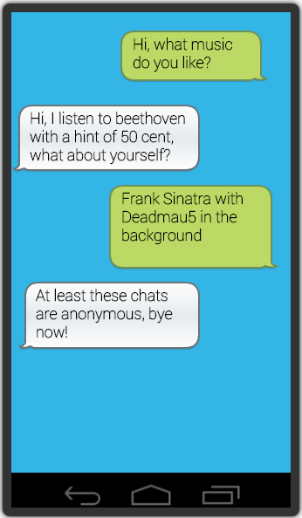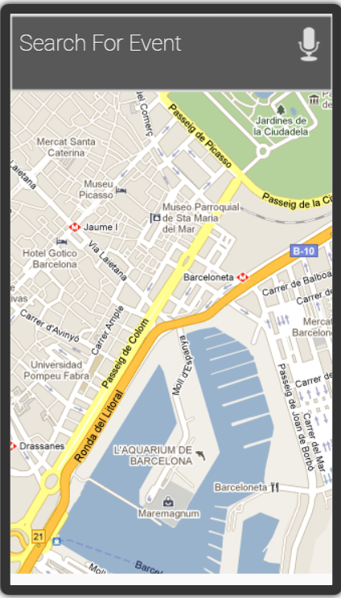Fluid UI Prototypes (GUI Mockups)

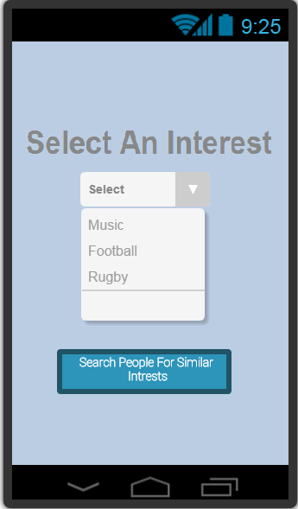

1- User can select their personal interest, and then search for users with similar interests

2 - Users and events will be marked on a map using the mobile client Global Positioning System (GPS)

3- Users will be able to select a user and start a chat, users will remain completely anonymous for the entire chat.

Targeted Users & Benefits

Primary

The app can be targeted to almost anybody who owns a smartphone and is interested in meeting new people based on similar interests or locations.

Secondary

The app can also be targeted towards event organisers, music festivals and rugby matches etc. Thus giving users who are interested in such events more reason to communicate with one another.

Benefits

The mobile application can bring many benefits to all users as well as event organisers such as:

1. Finding other users based around the same Geolocation who have similar interests
2. Allow simple text messaging between users
3. Finding events based around users Geolocation
4. Advertise logos for events

Key factors to judge quality

1. The user interface for both mobile client and web application must be clear and usable for all user levels
2. The mobile application should allow users to register their current centre of interests which will be stored on the Fi-Ware backend.

Main Functionalities

The core functionalities of this project are;

* Connect the mobile client to the Fi-Ware backend cloud infrastructure to send and store information (users’ centre of interests etc.)
* Send the location of the mobile client via GPS to the web application which is then stored on the Fi-Ware backend
* The web application should identify when two mobile clients with the same interests are in the same vicinity, mobile Clients are then allowed to communicate/chat anonymously by using their mobile data rather than phone number

Main Risks Summary

The main risks identified so far are:

Business Risks

* Competitors: there are many similar apps in the market at a free cost.
* Cost and revenues have not been estimated.
* Value Proposition: this has not been validated.

Technological Risks

* The Fi-Ware technology is still in development, quite all over the place with its development, may be hard to come to grips with the technology
* Updating the Geolocation of multiple users could be costly and time consuming
* Supporting many different clients is costly and time dependant

Project Risks

* New technologies for developers to learn and code

Functional Specification

Introduction

The aim of my project is to produce a smartphone app in which users can register their current centre of interests (hobbies, sports etc.).All information entered from the user must be stored using the Fi-Ware technology (the EU sponsored cloud solution).

The main goal of the project is to deliver a robust social networking app based on clients’ personal interests and locations. It is proposed that this will be achieved by:

* Create a mobile application.
* Create a cloud-based application using Fi-Ware technology.
* Allow Event Organisers to create events using a web based application.

Purpose

The purpose of this document is to provide a detailed description of the functionalities of the Fi-Ware Social Proximity Application. The document will cover each of the systems expected features, as well as provide a preview of User Interface mock up screens.

Scope

The main goal of the Fi-Ware Social Proximity Application is to create a unique experience of social media interaction. The Fi-Ware Social Proximity Application will allow users to search for locations based on their current interests around their current location. The Fi-Ware Social Proximity Application aims to give users a social experience in which they stay anonymous to other users who are currently around them and have the same interests.

The Fi-Ware Social Proximity App is intended for every day smartphone users who are willing to explore new mobile applications. The current functionalities of the application will establish strong ground for possible future expenditures of the mobile app.

Overall Description

This section will provide a general description of the application.

Product Perspective

The application context can be visualized from the diagram below. The Social Proximity application requires communicating with the device hardware for the GPS functionality. The GPS will be used for locating the users’ current position which can also be displayed on Google Map (with the use of the Google Maps API). The content of the mobile application will be stored on a virtual machine which is hosted via the Fi-Ware Infrastructure.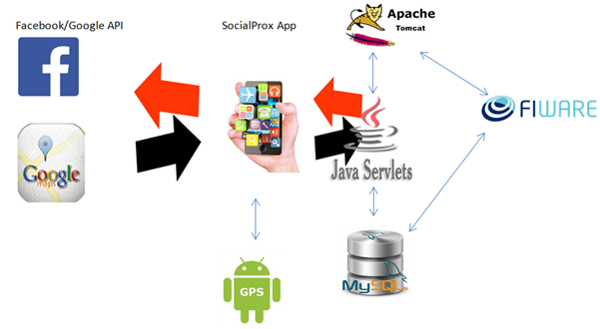

The virtual machine will have certain software installed on to it manually such as Apache Tomcat Java and MySQL. The mobile application will use RESTful API to communicate with Java Servlets which also communicate with the MySQL database.

Product Functions

This section of the document contains the main functionality details of the project. The order of the functionalities is written in the most important to least important.

User Classes and Characteristics

There can be up to three users who can interact with the system. Two of the users interact with the mobile client such as users who can sign in using a social network account (Facebook) or use the application as a guest. The other user would be a registered event organiser who can log into a web application to create events so that mobile clients can view them on the handheld device.

Operating Environment

The application will operate on Android smartphones with version Ice Cream Sandwich 4.0 and above.

Design and Implementation Constraints

The internet connectivity is a constraint for the Fi-Ware Social Proximity App, the application requires constant internet connectivity to interact with the cloud database to store and receive information. GPS is another constraint for the application functionality. The mobile application depends heavily on the GPS coordinates of the phones position to determine locations of interests around the user. GPS accuracy is dependent on manufactured embedded GPS chips, the quality of the GPS chips will determine how accurate the current location will be. However using the devices Wi-Fi connection to locate the current location can overcome this problem.

Assumptions

It is assumed that the application will be running on a device which has the appropriate system resources to the run smoothly. The application will not function or in some cases crash if the hardware resources were not available on a particular device.

Specific Requirements

External Interface Requirements

User Interface

The application user interface will grasp simplicity, it is proposed that the User Interface will be creative and will have the same look and feel throughout the application. The user will be provided with a very basic first screen which will allow them to log in using Facebook or to use the application as a guest. The diagrams below are prepared to illustrate the applications look and feel. However the User Interface objects will most likely change throughout the duration of the project.

**GPS Location with User Location.     Aiming for a top-based tabbed navigation system**

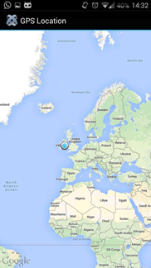

Hardware Interfaces

The application will have no direct communication. The communication with the hardware will be established through the use of provided operating system Application Programmable Interfaces and libraries.

Communication Interfaces

The application will provide the user with an optional ‘Log In With Facebook’. In order to complete this functionality the application will require communication with the Facebook server to allow a user so to sign in via Facebook. The application will also establish a communication with the Google Maps server for location purposes, again the communication will be established through the use of Google Maps API.

System Functionality

This section contains the functionality requirements of the Fi-Ware Social Proximity Application.

Functionality

Create Profile

The mobile client must select their current centre of interests (music, sport etc.) from a selected list along with basic personal information (gender, age) this information will exist for certain duration. A random name will be generated for the user profile after he/she has selected their current interest, this random name will be used if the user decides to chat anonymously with another mobile client.

Start Anonymous Chat

The mobile client will be able to communicate with another mobile client anonymously if they are within the same vicinity and have the same interests. The mobile clients will be prompted from the web application to decide whether or not they wish to chat.

Provide Location

The mobile client will be required to upload its location to the web app. The location of the mobile client can be found using the Global Positioning System (GPS) coordinates. The phones Geolocation along with the centres of interests will be automatically uploaded to the web app which will stay there for the specified duration.

Search Event

The mobile client will be able to search for an event that is in relation with their current interest, the user should be able to view all the events on a map based format.

Create Events

An event organiser will have the opportunity to create events via the web application. They will have the opportunity to customise events so that mobile clients can view them on the social proximity application.

Target Users

Social Media Enthusiasts

The application is targeted towards but not limited to social media enthusiast. The mobile application will be easy to use whilst also offering new functionality to social media fanatics.

Event Organisers

The application will also be targeted for event organisers who wish to promote events such as music festival and sports events.

Supplementary Specification

Objectives

The purpose of this document is to define requirements of the Fi-Ware Social Proximity Mobile App.

This Supplementary Specification lists the requirements that are not readily captured in the use cases of the use-case model. The Supplementary Specifications and the use-case model together capture a complete set of requirements on the system.

FURPS

Functionality

Connectivity

The application should be able to connect to the Fi-Ware server at any time when the device is connected to the internet.

Usability

Localization

The application will operate in English which is a global language. However it will be able to support multiple languages once translation resources are provided.

Feedback

The user will be provided with appropriate messages to help aid them in completing tasks (e.g. enter name here), the application will also inform the user about errors.

Look and Feel

The application will be designed to have the same look and feel throughout each screen. The font types, sizes and colouring will be of similar standard across the application.

Ease of Use

The mobile application must implement a user interface that is easy to grasp and understand for novice users. The create profile screen should be simple yet elegant therefore an expert mobile user should be able to complete the screen with under a minute.

Reliability

Availability

The application should be available for use at any time the user requires, although without internet connection the application won't be able to access any features.

Supportability

Reusability

The application will support automatic updates which will be taken place through the relevant native market (Google Play Store, iOS App Store). Updated versions of the application will be uploaded to the relevant market place which will prompt the user that an update is available.

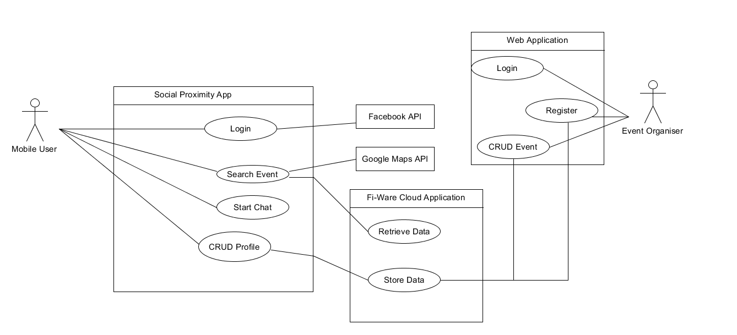 Use Case Diagram

Brief Use Cases

**Login**

Actors: Mobile User, Fi-Ware Cloud Application

Description: This use case begins when the mobile user launches the application and is prompted with the main screen. The mobile user can either use the application as a guest or sign in using their social network Facebook account. This use case concludes once the user has successfully signed in as a guest or using their Facebook account.

**CRUD Profile**

Actors: Mobile User, Fi-Ware Cloud Application

Description: This use case begins when a mobile users wishes to create, update or remove their profile. If a user is creating a profile he/she only have to enter a random user name and select a current interest from a selected list. The location of the phone will be found automatically. These details along with the phones Geolocation will be automatically sent to the web application where the data is stored on the Fi-Ware Cloud Application. This use case concludes once the user has successfully created, amended or deleted their profile.

**Search Event**

Actors: Mobile User, Fi-Ware Cloud Application

Description: This use case begins when a mobile user wishes to search for an event based on his/her current interests. The mobile user will select the search tab and will be prompted on a map display with events located around him/her based on their current interest. This use case ends when the user has successfully searched for an event.

**Register**

Actors: Event Organiser, Fi-Ware Cloud Application

Description: This use case begins when an event organiser wishes to register to gain access to the web application. The event organiser must enter the relevant information to register for the web application which is stored on the Fi-Ware Cloud. This use case end when the event organiser has successfully registered.

**Login**

Actors: Event Organiser, Fi-Ware Cloud Application

Description: This use case begins when an event organiser wishes to log into the web application to either create an event or update his or her account. The event organiser must enter his/her credentials to log into the system. This use case ends when the event organiser has successfully logged in.

**CRUD Event**

Actors: Event Organiser, Fi-Ware Cloud Application

Description: This use case begins when an event organiser has successfully logged into the web application and wishes to create update or remove an event. If the event organiser wishes to create a new event he/she must fill in the relevant information, the details of the event will be stored on the Fi-Ware Cloud. If the event organiser wishes to delete an event he/she can view all events that they have uploaded to the web application and can remove a particular event. This use case ends when an event organiser has successfully created or removed and event.

Detailed Use Cases

**Login**

**Actors:** Mobile User, Fi-Ware Cloud Infrastructure

**Main Success Scenario:**

1. The user launches the mobile application and is brought to the main screen.
2. The user has the option to log in as a guest or using their social networking Facebook account.
3. If the user selects log in as guest they are brought directly to the create profile screen.
4. If the user logs in with Facebook the Social Proximity application communicates with the Facebook API to process log in.
5. The mobile user is then prompted to enter their Facebook credentials.
6. The user must allow permission from their Facebook account to be used with Social Proximity
7. The user is then brought to the create profile screen.

**Alternatives**

4a

The mobile device Wi-Fi or mobile data is disabled.

1. The Social Proximity App and Facebook API can’t communicate.

5a

The mobile users Facebook credentials are in correct.

1. The Facebook API login form will inform the user that their credentials are incorrect.

**CRUD Profile**

**Actors:** Mobile User, Fi-Ware Cloud Infrastructure

**Main Success Scenario:**

1. The user arrives at the application main screen and logs in as a guest or with Facebook.
2. The application then brings the mobile client to the create profile page.
3. Once the user interacts with the create profile page the longitude and latitude are automatically obtained and filled in for the user.
4. The user must enter an anonymous user name and select their current interest from the drop down menu.
5. The user taps the submit button to create his/her profile.

**Alternatives**

3a

The users’ mobile device has GPS disabled.

1. The application displays an alert dialog box to the user informing them that their GPS is disabled.

4a

The mobile device Wi-Fi or mobile data is disabled.

1. Create profile will not complete successfully and the mobile application will display that the current page can’t be accessed.

**Preconditions**

1. The user has not signed in.

**Postconditions**

1. The user has already created a profile.

**Register**

**Actors:** Event Organiser, Web Application, Fi-Ware Cloud Infrastructure

**Main Success Scenario:**

1. The event organiser arrives at the registration pages and wants to register to the web application.
2. The event organiser fills out the web application form and enters credentials such as login id, password and email address.
3. The event organiser submits the form in which the details are stored on a remote database on the Fi-Ware Cloud.
4. The event organiser is redirected to the login page so that he/she can login using their new account details.

**Alternatives:**

2a

The login id credential already exists.

1. The web application will inform the event organiser that the user name already exists and is promoted to enter a different user name.

**Postconditions**

1. The user has already created an account.

**Create Event**

**Actors:** Event Organiser, Web Application, Fi-Ware Cloud Infrastructure

**Main Success Scenario:**

1. A registered event organiser who has successfully logged in wishes to create an event.
2. The event organiser directs themselves to the create event page.
3. The event organiser then starts filling out the web application form.
4. The event organiser then selects an event logo to upload.
5. The event organiser submits the form.
6. The event is successfully created and stored in the corresponding database depending on the type of event.
7. The event organiser is redirected to the menu page.

**Alternatives:**

3a

The web application form can’t automatically get the longitude or latitude of the current event organiser position as the browser may not support the function.

1. The user can enter the longitude latitude manually

**Preconditions**

1. The event organiser has not logged in.
2. The event organiser has not registered to the web application

**Postconditions**

1. The event organiser has already created an event.

References

[1]

*Emarketer.com, (2014). Smartphone Users Worldwide Will Total 1.75 Billion in 2014 - eMarketer. [Online] Available at:* [*http://www.emarketer.com/Article/Smartphone-Users-Worldwide-Will-Total-175-Billion-2014/1010536*](http://www.emarketer.com/Article/Smartphone-Users-Worldwide-Will-Total-175-Billion-2014/1010536)

*[Accessed 6 Oct. 2014].*

[2]

*Facts, M. (2014). Topic: Mobile App Usage. [Online] www.statista.com. Available at:* [*http://www.statista.com/topics/1002/mobile-app-usage/*](http://www.statista.com/topics/1002/mobile-app-usage/)

*[Accessed 6 Oct. 2014].*